Chapter 19, Solution 16.

For the circuit in Fig.19.77, at w = 2 rad/s, z₁₁ = 10 Ω, z₁₂ = z₂₁ = j6 Ω, z₂₂ = 4 Ω.
Obtain the Thèvenin equivalent circuit at terminals a-b and calculate v_{o}.

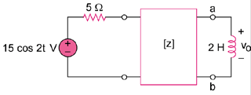

Figure 19.77
For Prob. 19.16.

Solution

As a reciprocal two-port, the given circuit can be represented as shown in Fig. (a).

At terminals a-b,

4 – j6

5

150 V

(a)

a

b

j6

j4
+

10 – j6

The Thevenin equivalent circuit is shown in Fig. (b).

6.4

690 V

(b)

j4
+

+

V_{o}

From this,

